AUTOKAR MAN DKL LY91 –liczba miejsc 57+1+1

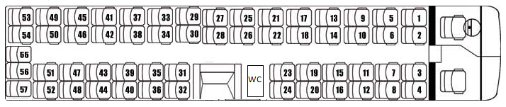

1 |  | 21 |  | 41
2 |  | 22 |  | 42
3 |  | 23 |  | 43
4 |  | 24 |  | 44
5 |  | 25 |  | 45
6 |  | 26 |  | 46
7 |  | 27 |  | 47
8 |  | 28 |  | 48
9 |  | 29 |  | 49
10 |  | 30 |  | 50
11 |  | 31 |  | 51
12 |  | 32 |  | 52
13 |  | 33 |  | 53
14 |  | 34 |  | 54
15 |  | 35 |  | 55
16 |  | 36 |  | 56
17 |  | 37 |  | 57
18 |  | 38 |  | 58
19 |  | 39 |  | 59
20 |  | 40

