AUTOKAR SETRA 516HD –liczba miejsc 53+2+1

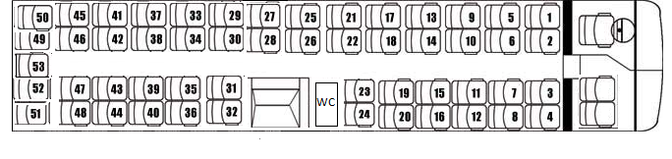

1 |  | 19 |  | 37
2 |  | 20 |  | 38
3 |  | 21 |  | 39
4 |  | 22 |  | 40
5 |  | 23 |  | 41
6 |  | 24 |  | 42
7 |  | 25 |  | 43
8 |  | 26 |  | 44
9 |  | 27 |  | 45
10 |  | 28 |  | 46
11 |  | 29 |  | 47
12 |  | 30 |  | 48
13 |  | 31 |  | 49
14 |  | 32 |  | 50
15 |  | 33 |  | 51
16 |  | 34 |  | 52
17 |  | 35 |  | 53
18 |  | 36

